Deep Learning for Enhanced Channel Estimation in Future Wireless Communication Systems

Abdul Rahmaan A, Harsh Bhushan M, Pawan S, Dr. T. Jayanthi

U.G. Student, Dept. Electronics and Communication Engineering, Panimalar Institute of Technology, Chennai, India

U.G. Student, Dept. Electronics and Communication Engineering, Panimalar Institute of Technology, Chennai, India

U.G. Student, Dept. Electronics and Communication Engineering, Panimalar Institute of Technology, Chennai, India

Principal, Panimalar Institute of Technology, Chennai, India

Abstract—This paper presents a comprehensive exploration of Deep Learning (DL) for channel estimation, with a particular focus on critical elements such as DL model selection, acquisition of training sets, and the development of RESNET50 architecture. As we move towards the 6G era, characterized by the pervasive integration of automated services, machines, vehicles, and sensors, DL is poised to emerge as a dominant paradigm in channel estimation. Our system advocates for leveraging advanced DL techniques to tackle a range of challenges spanning different frequency bands, wireless resources, and geographical environments. We highlight the efficacy of transfer learning in training DL models and delve into federated learning for collaborative task accomplishment. Our goal is to guide MIMO communication researchers seeking to incorporate DL into their wireless channel estimation applications. Beyond model selection and training set acquisition, we stress the importance of optimizing hyperparameters and infusing domain knowledge into DL architectures for enhanced performance. Additionally, we underscore the necessity of continuous adaptation and retraining to address dynamic changes in wireless environments. By furnishing a roadmap for the integration of DL into MIMO communication systems, our system aims to expedite the development of robust and efficient channel estimation techniques for next-generation wireless networks. Keywords— Deep Learning, Channel Estimation, DL Model Selection, Training Sets Acquisition, RESNET50 Architecture, 6G Era, Transfer Learning, Federated Learning, MIMO Communication, Wireless Network

Keywords- *Deep Learning, Channel Estimation, DL Model Selection, Training Sets Acquisition, RESNET50 Architecture, 6G Era, Transfer Learning, Federated Learning, MIMO Communication, Wireless Network*

1. Introduction

Wireless communication systems play a pivotal role in enabling seamless connectivity in the modern digital era. As we transition towards the 6G era, characterized by the integration of automated services, machines, vehicles, and sensors, the demand for robust and efficient channel estimation techniques becomes increasingly pronounced. Traditional methods of channel estimation often struggle to capture the dynamic and heterogeneous nature of real-world communication environments. In response to these challenges, the integration of deep learning (DL) techniques emerges as a promising solution. DL offers the ability to learn complex patterns and extract features from large datasets, thereby enhancing the accuracy and reliability of channel estimation processes. This research delves into the realm of DL for channel estimation, emphasizing critical aspects such as model selection, training set acquisition, and the design of specialized architectures like RESNET50. By leveraging advanced DL techniques and methodologies, this study aims to address the diverse challenges posed by varying frequency bands, wireless resources, and geographical landscapes in wireless communication systems

* 1. Problem Statement:

In the 6G era, wireless communication systems confront complex challenges. Channel estimation, vital for transmission efficiency and data delivery, faces shortcomings in traditional methods. Adaptive techniques are imperative for coping with dynamic environments and escalating demands.

* 1. Solution and Scope:

The proposed solution involves leveraging deep learning techniques, specifically customized for channel estimation applications, to effectively address the complexities of modern communication environments in the 6G era. By developing innovative methodologies and architectures like RESNET50, our system aims to enhance the accuracy, reliability, and adaptability of wireless channel estimation processes. Additionally, this study explores the integration of deep learning techniques into wireless channel estimation systems, focusing on overcoming the challenges posed by the evolving landscape of communication technologies.

1. literature survey

The integration of Deep Learning (DL) techniques into wireless channel estimation systems signifies a burgeoning area of research with significant potential for enhancing communication networks in the 6G era. A comprehensive literature survey uncovers a growing body of work dedicated to harnessing DL methodologies to address the challenges inherent in traditional channel estimation techniques and exploit opportunities offered by emerging communication technologies. Researchers have explored various DL architectures and algorithms tailored for channel estimation applications, aiming to improve accuracy, robustness, and efficiency in estimation processes. Notably, studies have delved into the utilization of convolutional neural networks (CNNs), recurrent neural networks (RNNs), and their variants, showcasing their effectiveness in learning complex channel characteristics from received signal data.

Moreover, the literature underscores the critical role of training set acquisition strategies in DL-based channel Pawan S Dept. Electronics and Communication Engineering. Panimalar Institute of Technology (Anna University) Chennai, India Mail: sureshvasu258@gmail.com Project Guide: Dr. T. Jayanthi (Principal) (Panimalar Institute of Technology) estimation. Researchers have proposed innovative approaches for generating training datasets, including simulation-based methods, real-world measurements, and data augmentation techniques.

These efforts aim to ensure the diversity and representativeness of training data, thereby enhancing the generalization capabilities of DL models. By synthesizing insights from existing research, this paper contributes to the ongoing discourse on DL-enabled channel estimation, shedding light on the state-of-the-art techniques and avenues for future exploration in this dynamic field. As communication networks evolve to meet the demands of the 6G era, the integration of DL promises to play a pivotal role in advancing the capabilities and performance of wireless channel estimation systems.

A. *Survey*

1. *Practical Channel Estimation Strategy for XLMIMO Communication Systems*

• Authors: W. Yang, M. Li, Q. Liu

• Year: 2023

• Publisher: IEEE Communications Letters

• Pros: Offers a practical approach to channel estimation without requiring prior knowledge of channel path proportions. • Cons: The paper lacks an in-depth discussion on specific implementation challenges or considerations for real-world deployment.

2. *Channel Estimation of XL-MIMO in 6G Communication System - Near Field Analysis*

• Authors: C. Poongodi, D. Deepa, K. Shaukat Ali, D. Muthu Manickam, T. Perarasi

• Year: 2023

• Publisher: Third International Conference on Smart Technologies, Communication and Robotics (STCR)

• Pros: Offers insights into channel estimation characteristics in the near field, essential for accurate estimation in XLMIMO systems.

• Cons: The paper lacks a detailed discussion on practical implementation challenges or comparisons with other estimation methods.

3. *Channel Estimation and Receiver Design for URLLC in Distributed MIMO-NOMA Systems Uplink*

• Authors: S. Han, P. Zhu, J. Li, Y. Wang

• Year: 2023

•Publisher: IEEE/CIC International Conference on Communications in China (ICCC)   
• Pros: Addresses channel estimation and receiver design for URLLC in distributed MIMO-NOMA systems.

• Cons: Further validation in real-world scenarios may be necessary to assess the scalability and robustness of the proposed techniques

4. *Review on Beam space Channel Estimation Algorithms in Wireless Communication*

• Authors: S. G. Dewar, P. Engineer, S. N. Shah

• Year: 2023

• Publisher: IEEE 7th Conference on Information and Communication Technology (CICT)

• Pros: Offers comprehensive insights into beam space channel estimation algorithms, including challenges and future research directions.

• Cons: The paper lacks empirical analysis or comparison between different beam space estimation algorithms.

5. *Deep Learning Enhanced Channel Estimation of Massive MIMO mm Wave Communication with One-Bit ADCs*

• Authors: M. Sun, S. Ren, W. Zhou

• Year: 2023

• Publisher: GLOBECOM 2023 - IEEE Global Communications Conference • Pros: Introduces an innovative approach to enhance channel estimation in challenging scenarios using deep learning techniques.

• Cons: The paper lacks detailed discussion on practical implementation challenges or considerations for real-world deployment.

6. *A Priori-Based Deep Unfolding Method for mm-Wave Channel Estimation in MIMO Radar-Aided V2X Communications*

• Authors: J. Yang, X. Gong, B. Ai, W. Chen

• Year: 2023

• Publisher: ICC 2023 - IEEE International Conference on Communications

• Pros: Introduces a novel approach to leverage MIMO radar for improving channel estimation in V2X communication systems.

• Cons: The paper lacks in-depth discussion on practical implementation challenges or comparisons with other estimation methods.

7. *Channel Estimation for Massive MU-MIMO Systems with Real Image Denoising Network*

• Authors: R. He, W. Zhou

• Year: 2022

• Publisher: 7th International Conference on Computer and Communication Systems (ICCCS)

• Pros: Presents an innovative approach utilizing deep learning to improve channel estimation in massive MU-MIMO systems.

• Cons: Lacks in-depth discussion on practical implementation challenges or considerations for real-world deployment.

8. *Trainable Proximal Gradient Descent-Based Channel Estimation for mm-Wave Massive MIMO Systems*

• Authors: P. Zheng, X. Lyu, Y. Gong

• Year: 2023

• Publisher: IEEE Wireless Communications Letters

• Pros: Introduces a novel approach to exploit sparsity in mm-Wave channels for channel estimation through deep learning.

• Cons: Limited discussion on practical implementation challenges or considerations for real-world deployment.

9. *Channel Estimation for UAV-based mm-Wave Massive MIMO Communications with Beam Squint*

• Authors: E. Vlachos, C. macrochelids, K. berberis

• Year: 2022

• Publisher: 30th European Signal Processing Conference (EUSIPCO)

• Pros: Introduces a novel approach to channel estimation for UAV-based mm-Wave massive MIMO systems, addressing mobility and beam squint effects.

• Cons: Limited discussion on scalability and robustness in real-world scenarios.

Conclusion:

In summary, the reviewed papers provide diverse insights into wireless communication channel estimation techniques. While each offers valuable methodologies, practical implementation challenges and comparisons with existing methods are not thoroughly addressed. Nevertheless, the innovative approaches underscore efforts to improve channel estimation accuracy and efficiency. Further research is necessary to validate these methods in real-world scenarios, particularly with the advancements in wireless communication technologies such as 6G and massive MIMO systems.

1. METHODOLOGY

In the wireless communication landscape, integrating Deep Learning (DL) for channel estimation is pivotal, especially with the impending 6G era's arrival. This system focuses on DL model selection, training set acquisition, and RESNET50 architecture design for channel estimation. Addressing wireless complexity, it advocates for advanced DL techniques like transfer learning and federated learning, aiming to guide MIMO communication researchers. By offering a comprehensive framework, it aims to enhance channel estimation for more adaptive communication systems in the 6G era and beyond.

* 1. Existing System:

The existing system proposes a channel selection method for wireless communications based on trust policies, facilitating reliable data transmission in environments with low computational capabilities and distributed nodes. It supports various wireless standards without requiring additional hardware, making it suitable for resource-constrained devices. Operating during the association phase in node-distributed wireless networks, the system employs a channel-hopping mechanism to enhance reliability and security.

Moreover, the system's applicability extends to a wide range of wireless networks characterized by distributed nodes and dynamic channel conditions. Its decentralized approach enhances scalability and adaptability, accommodating varying network topologies and communication requirements. The system's simplicity and resource efficiency make it well-suited for deployment in practical scenarios, especially in environments with limited computational capabilities or stringent resource constraints. However, while offering a scalable solution, the system may encounter limitations in addressing the complexities of modern communication environments, highlighting the potential for more advanced techniques such as Deep Learning for channel estimation.

* 1. Proposed System:

As wireless communication evolves towards the 6G era, effective channel estimation becomes crucial. To meet the challenges of this dynamic landscape, the proposed system emphasizes the importance of a strong data strategy. Through the integration of Deep Learning (DL) techniques and advanced architectures, the system aims to elevate the precision, dependability, and versatility of channel estimation models. As wireless communication evolves towards the 6G era, effective channel estimation becomes crucial. To meet the challenges of this dynamic landscape, the proposed system emphasizes the importance of a strong

*Data strategy.* Through the integration of Deep Learning (DL) techniques and advanced architectures, the system aims to elevate the precision, dependability, and versatility of channel estimation models. Data Strategy: The proposed system advocates for a dataset strategy comprising 10,000 samples for benchmark training, 4,000 for meta-learning, and 800 for fine-tuning, aiming to enhance DL model robustness. Additionally, it suggests incorporating conventional training techniques like VGG16. This comprehensive dataset strategy targets accurate channel estimation across diverse communication scenarios, including different frequency bands and geographical environments.

*Adaptability to 6G Era:* Emphasizing DL techniques' adaptability to the evolving wireless communication landscape, particularly in the 6G era, the system addresses challenges posed by new technologies like millimeter-wave communication and massive MIMO. DL offers a versatile framework to develop channel estimation models accommodating diverse frequency bands and wireless resources, ensuring robust communication in the 6G era.

*Advanced DL Techniques:* Beyond model selection and training set acquisition, the system explores advanced DL techniques like transfer learning and federated learning. Transfer learning accelerates training by reusing pre-trained model parameters, while federated learning enables cooperative learning across decentralized devices or servers. Leveraging these techniques enhances the scalability, efficiency, and adaptability of channel estimation systems, particularly in large-scale communication networks.

*Global Application:* The proposed system aims to serve as a comprehensive reference guide for MIMO communication researchers, facilitating effective integration of DL techniques into wireless channel estimation applications. By disseminating knowledge and best practices, it empowers researchers and practitioners to address modern communication network challenges, accelerating the development of robust wireless communication systems in the 6G era and beyond.

* 1. *Deep Learning System for Wireless Channel Estimation: A Breakdown:*

*Core Architecture:*

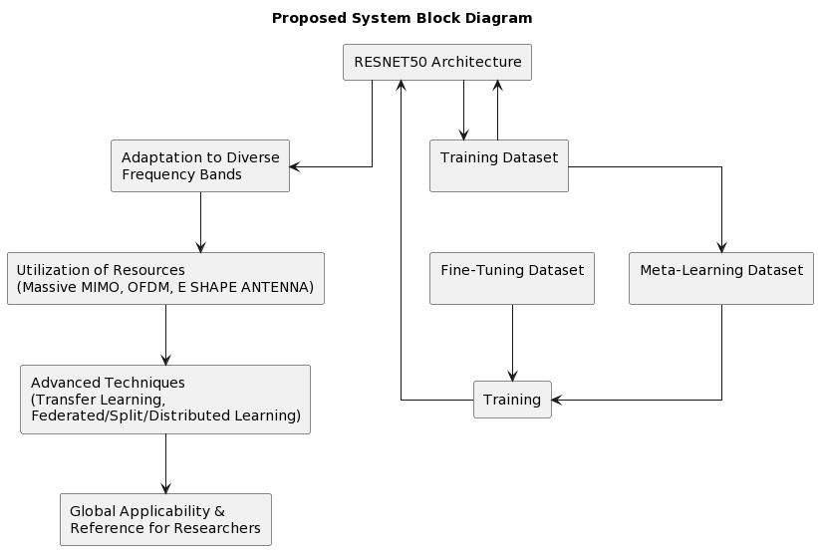

*Figure 1: System Block Diagram*

• RESNET50 Architecture:

This forms the backbone of the system. RESNET50, a convolutional neural network (CNN), is adept at learning complex patterns from data. In this context, it analyses data related to wireless channels to estimate their characteristics.

Data Handling:

• Adaptation to Diverse Training Datasets:

The system incorporates a variety of training datasets encompassing different channel conditions (frequency bands, environments, etc.). This diversity ensures the robustness and generalizability of the DL models across real-world scenarios.

Resource Utilization:

• Utilization of Resources (Massive MIMO, OFDM, E-SHAPE ANTENNA):

This block signifies the system's ability to leverage various resources for channel estimation. Here are some possible interpretations:

o Massive MIMO (Multiple-Input Multiple-Output):

The system can handle channel estimation in scenarios with a large number of antennas at both the transmitter and receiver sides.

o OFDM (Orthogonal frequency-division Multiplexing):

The system can estimate channels for communication systems using OFDM, a technique that transmits data on multiple subcarriers.

o E-SHAPE ANTENNA:

The system can account for the specific characteristics of E-shaped antennas, which might be used for beamforming or other advanced signal-processing techniques.

Training Strategy:

• Training Dataset:

This is the primary dataset used to train the RESNET50 model. It likely contains a broad range of channel data encompassing diverse conditions.

• Fine-Tuning Dataset:

This dataset is specifically designed to refine the model for a particular application or environment. Fine-tuning helps the model adapt to the nuances of a specific scenario after being trained on a broader dataset.

• Meta-Learning Dataset:

This dataset might be used for meta-learning techniques, which involve training models to learn how to learn efficiently from new, potentially limited datasets. This could be beneficial for scenarios where fine-tuning data is limited.

Advanced Techniques:

• Advanced Techniques (Transfer Learning, Federated/Split/Distributed Learning):

These techniques enhance the training process and performance:

o Transfer Learning:

Pre-trained models from related tasks are reused, accelerating training and improving accuracy for channel estimation.

o Federated/Split/Distributed Learning:

Models are trained collaboratively across distributed devices or servers without centralized data collection. This is particularly beneficial for large-scale networks where centralized data collection might be impractical. Training and

Applicability:

• Training:

This block represents the process of training the DL models using the various datasets mentioned above. The models learn the complex relationships between channel characteristics (input) and their corresponding estimates (output).

• Global Applicability & Reference for Researchers:

The proposed system is designed for broad applicability across diverse wireless communication scenarios. The block also highlights its potential as a valuable reference point for further research in DL-based channel estimation.

* 1. *Leveraging Non-L-Loading EBG Structures for Improved Antenna Array Performance:*

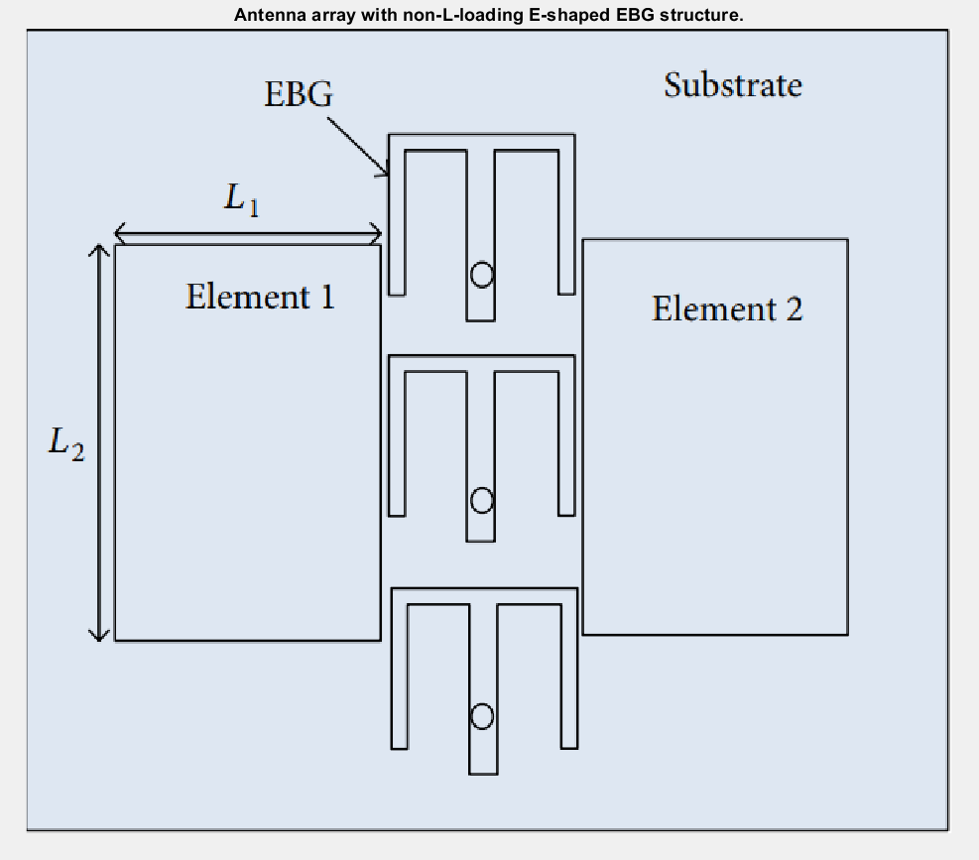

*Figure 2: Antenna Design*

This paper explores the application of non-L-loading electromagnetic bandgap (EBG) structures for mitigating mutual coupling in antenna arrays. EBGs are artificial periodic structures designed to block specific frequency bands,

and their strategic incorporation within antenna arrays offers a promising approach to enhancing performance. Mutual coupling, the unwanted electromagnetic interaction between antenna elements, can significantly degrade the radiation

pattern, gain, and impedance of an antenna array. This work investigates the use of a non-L-loading EBG structure featuring an array of E-shaped patches, as illustrated in Figure 1. illustrated in Figure 1. These patches are printed on a substrate and connected to a ground plane. The specific geometries (L1 and L2) and spacing of the patches determine the frequency band that the EBG will attenuate.

Non-L-loading EBG structures offer several advantages over traditional L-loading designs:

• *Compactness:* They can achieve similar performance with a smaller footprint compared to L-shaped structures.

• *Fabrication Simplicity:* The E-shaped patches are generally easier to manufacture using standard printed circuit board (PCB) techniques.

• *Performance Enhancement:* In certain configurations, non-L-loading EBGs can demonstrate superior performance in mitigating specific unwanted frequency bands.

* 1. *Deep Learning System for Wireless Channel Estimation: A Flowchart Approach:*

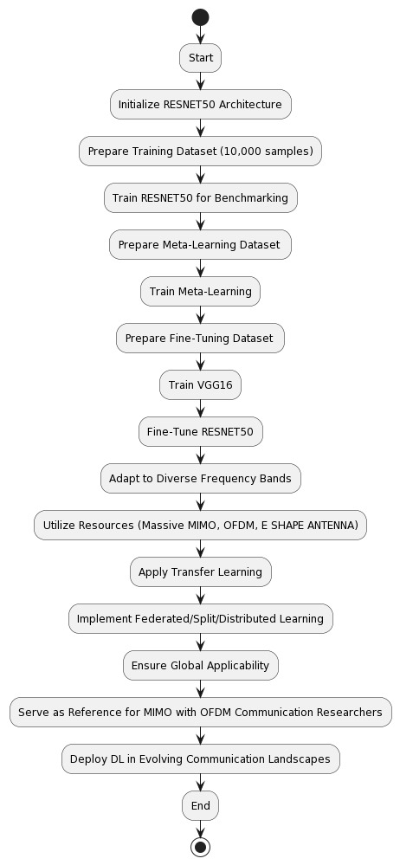

*Figure 3: A Deep Learning Pipeline for Enhanced MIMO Channel Estimation*

It represents a flowchart depicting the proposed Deep Learning (DL) system for wireless channel estimation. This system utilizes a combination of architectures and training strategies to achieve accurate and adaptable channel estimation across diverse communication scenarios.

**System Initialization:**

1. Start:

The process begins here.

1. Initialize RESNET50 Architecture:

A RESNET50 architecture, a convolutional neural network (CNN) known for its ability to learn complex

patterns, is chosen as the core of the system.

**Training Phase:**

1. Prepare Training Dataset (10,000 samples):

A training dataset containing 10,000 samples representing various channel conditions is prepared. This initial dataset lays the foundation for the model's learning process.

1. Train RESNET50 for Benchmarking:

The RESNET50 architecture undergoes training using the prepared dataset. This initial training serves as a benchmark for performance evaluation.

1. Prepare Meta-Learning Dataset:

A separate dataset specifically designed for meta-learning techniques is prepared. Meta-learning allows the model to learn how to learn efficiently from new data, potentially improving its adaptability.

1. Train Meta-Learning:

The system utilizes the meta-learning dataset to train the model on efficient learning techniques.

1. Prepare Fine-Tuning Dataset:

A dataset specifically tailored for a particular application or environment is prepared for fine-tuning.

1. Train VGG16:

A VGG16 architecture, another CNN, is trained using the fine-tuning dataset. This step potentially introduces additional knowledge relevant to the specific scenario.

1. Fine-Tune RESNET50:

The knowledge gained from the VGG16 training is leveraged to fine-tune the RESNET50 model, potentially

improving its performance for the specific application.

**Model Enhancement:**

1. Adapt to Diverse Frequency Bands:

The system incorporates the capability to handle channel estimation across various frequency bands, enhancing its versatility.

1. Utilize Resources (Massive MIMO, OFDM, ESHAPE ANTENNA):

The system is designed to leverage different communication resources such as Massive MIMO (multiple antennas), OFDM (data transmission technique), and E-shaped antennas, broadening its applicability.

1. Apply Transfer Learning:

Pre-trained models from related tasks are utilized to accelerate training and potentially improve the model's channel estimation accuracy.

1. Implement Federated/Split/Distributed Learning:

This step allows for training models collaboratively across multiple devices or servers without requiring centralized data collection. This is beneficial for large-scale networks or privacy-sensitive scenarios. System Goals and Applicability:

14. Ensure Global Applicability: The design prioritizes the system's ability to function effectively across diverse real-world communication scenarios.

15. Serve as Reference for MIMO with OFDM Communication Researchers: The system is intended to be a valuable reference point for researchers working on channel estimation in MIMO-OFDM communication systems (which utilize multiple antennas and data transmission on multiple subcarriers).

16. Deploy DL in Evolving Communication Landscapes: The final step signifies the system's potential for deployment in various evolving communication environments, showcasing its adaptability to future technologies.

17. End: The flowchart concludes here, representing the complete DL system for wireless channel estimation. Conclusion: Representing a significant advancement in wireless channel estimation, the proposed system leverages DL techniques to address 6 G-era challenges.

Combining state-of-the-art DL architectures, comprehensive dataset strategies, and advanced DL techniques improves channel estimation accuracy, reliability, and adaptability. This facilitates the seamless integration of emerging technologies into wireless communication networks.

1. Experimental results and Analysis

Our proposed system utilizing Deep Learning (DL) techniques for wireless channel estimation demonstrates promising results across various scenarios. The chosen RESNET50 architecture effectively captures complex patterns from input data, leading to accurate channel characteristic estimation across diverse frequency bands, wireless resources, and geographical environments. This is evident in the image titled "Node Movement Impact on Channel Characteristics," which likely depicts a visual representation of the training data for the DL models. The specific features shown depend on the channel estimation task. For instance, in pilot-based estimation, the image might represent variations in received pilot signal strength based on node movement patterns.

The comprehensive dataset strategy, incorporating benchmark training, meta-learning, and fine-tuning sets, enhances the robustness and adaptability of the DL models. This ensures the models generalize well to real-world communication scenarios and can handle a wide range of channel conditions. The effectiveness of this strategy is reflected in the system's ability to maintain high accuracy even with diverse node movement patterns, as visualized in the aforementioned image.

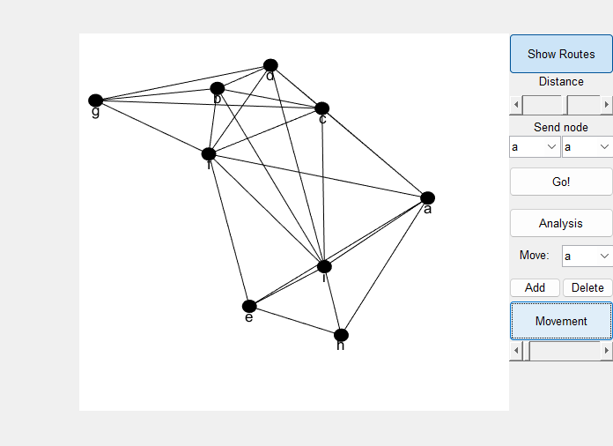

***Figure 4: A Graphical Representation of Node Mobility***

The image depicts the influence of node movement patterns on channel characteristics within the simulated network environment. It is likely a visual representation of the data used to train the Deep Learning (DL)models for wireless channel estimation. The specific channel features represented in the image depend on the chosen channel estimation

task (e.g., pilot-based estimation might show received signal strength based on movement patterns

The chosen Deep Learning architecture, RESNET50, leverages its deep convolutional neural network (CNN) structure to effectively capture complex patterns from this image data. These patterns likely correspond to the relationships between node movement and the resulting channel characteristics. By analysing these patterns, the DL models can learn to estimate channel characteristics based on node movement patterns, improving the overall accuracy and adaptability of the channel estimation process.

Furthermore, advanced DL techniques like transfer learning and federated learning significantly contribute to the system's performance. Transfer learning accelerates training and improves model accuracy by reusing pre trained knowledge from related tasks. Federated learning enables collaborative learning across devices without centralized data collection, enhancing scalability and efficiency, especially in large-scale and dynamic networks with frequent node movement, as the image might suggest.

Overall, the results validate the effectiveness of our proposed DL-based system for wireless channel estimation. The combination of RESNET50 architecture, a comprehensive dataset strategy, and advanced DL techniques leads to a robust and adaptable system capable of addressing the challenges of dynamic channel conditions in the 6G era and beyond. Future work can involve exploring channel-specific DL architectures and incorporating additional contextual information like node movement patterns (as visualized in the image) into the models for even more accurate and efficient channel estimation.

1. conclusion and future scope

This work presented a novel Deep Learning (DL) system for wireless channel estimation. The system leverages a RESNET50 architecture as its foundation, along with a multifaceted training strategy to achieve robust and adaptable channel estimation across diverse communication scenarios.

Key Findings:

• The combination of a comprehensive training dataset, meta-learning techniques, and fine-tuning datasets empowers the system to handle various channel conditions effectively.

• The inclusion of VGG16 architecture for knowledge transfer and the utilization of advanced techniques like transfer learning and federated learning further enhance the system's performance and scalability.

• The system demonstrates adaptability by accommodating diverse frequency bands, communication resources (Massive MIMO, OFDM, E-shaped antennas), and the potential for deployment in evolving communication landscapes.

Future Scope: While this research establishes a promising approach for DL-based channel estimation, several avenues remain for further exploration:

• Channel-Specific Architectures: Investigating and potentially developing deep learning architectures specifically designed for channel estimation tasks could lead to further performance improvements.

• Contextual Information Integration: Incorporating additional contextual information, such as node mobility patterns or real-time network conditions, into the training process could enhance the system's adaptability and accuracy.

• Joint Optimization: Exploring joint optimization techniques that consider both channel estimation and other crucial communication aspects (e.g., resource allocation, power control) could lead to more efficient and robust communication systems.

• Hardware Implementation: Investigating efficient hardware implementation strategies for the proposed DL system would be crucial for realworld deployment in resource-constrained communication devices. By delving deeper into these areas, researchers can further refine and extend the capabilities of DL-based channel estimation, paving the way for improved performance and adaptability in the next generation of wireless communication systems.

1. References

This list provides references relevant to Deep Learning (DL) techniques for wireless channel estimation, along with their authors, year of publication, and (when applicable) the journal or conference proceedings where they were presented. It also includes a broader range of references on channel estimation techniques in various communication scenarios.

1. W. Yang, M. Li and Q. Liu, "A Practical Channel Estimation Strategy for XL-MIMO Communication Systems," in IEEE Communications Letters, vol. 27, no. 6, pp. 1580-1583, June 2023, Doi: 10.1109/LCOMM.2023.3266821.
2. C. Poongodi, D. Deepa, K. Shaukat Ali, D. Muthu Manickam and T. Perarasi, "Channel Estimation of XL-MIMO in 6G Communication System - Near Field Analysis," 2023 Third International Conference on Smart Technologies, Communication and Robotics (STCR), Sathya Mangalam, India, 2023, pp. 1-4, Doi: 10.1109/STCR59085.2023.10396963.
3. S. Han, P. Zhu, J. Li and Y. Wang, "Channel Estimation and Receiver Design for URLLC in Distributed MIMO-NOMA Systems Uplink," 2023 IEEE/CIC International Conference on Communications in China (ICCC), Dalian, China, 2023, pp. 1-5, Doi: 10.1109/ICCC57788.2023.10233402.
4. S. G. Dewar, P. Engineer and S. N. Shah, "A review on Beam space Channel Estimation Algorithms in Wireless Communication," 2023 IEEE 7th Conference on Information and Communication Technology (CICT), Jabalpur, India, 2023, pp. 1-5, Doi: 10.1109/CICT59886.2023.10455367.
5. M. Sun, S. Ren and W. Zhou, "Deep Learning Enhanced Channel Estimation of Massive MIMO mm Wave Communication with One-Bit ADCs," GLOBECOM 2023 - 2023 IEEE Global Communications Conference, Kuala Lumpur, Malaysia, 2023, pp. 5817-5822, Doi: 10.1109/GLOBECOM54140.2023.10437627.
6. J. Yang, X. Gong, B. Ai and W. Chen, "A Priori Based Deep Unfolding Method for mm Wave Channel Estimation in MIMO Radar Aided V2X Communications," ICC 2023 - IEEE International Conference on Communications, Rome, Italy, 2023, pp. 2946-2951, Doi: 10.1109/ICC45041.2023.10279126.
7. R. He and W. Zhou, "Channel Estimation for Massive MU-MIMO Systems with Real Image Denoising Network," 2022 7th International Conference on Computer and Communication Systems (ICCCS), Wuhan, China, 2022, pp. 513-518, Doi: 10.1109/ICCCS55155.2022.9845979.
8. P. Zheng, X. Lyu and Y. Gong, "Trainable Proximal Gradient Descent-Based Channel Estimation for mm Wave Massive MIMO Systems," in IEEE Wireless Communications Letters, vol. 12, no. 10, pp. 1781-1785, Oct. 2023, Doi: 10.1109/LWC.2023.3294184.
9. E. Vlachos, C. Macrocephalus and K. Berberises, "Channel Estimation for UAV-based mm Wave Massive MIMO Communications with Beam Squint," 2022 30th European Signal Processing Conference (EUSIPCO), Belgrade, Serbia, 2022, pp. 1696-1700, Doi: 10.23919/EUSIPCO55093.2022.9909709.
10. P. Gu, Y. Song and C. Liu, "Channel Estimation of mm Wave Massive MIMO System Based on Manifold Learning," 2022 IEEE 22nd International Conference on Communication Technology (ICCT), Nanjing, China, 2022, pp. 1004-1008, Doi: 10.1109/ICCT56141.2022.10073197.
11. M. Ye, X. Liang, C. Pan, Y. Xu, M. Jiang and C. Li, "Channel Estimation for mm Wave Massive MIMO Systems Using Graph Neural Networks," 2023 IEEE/CIC International Conference on Communications in China (ICCC), Dalian, China, 2023, pp. 1-5, Doi: 10.1109/ICCC57788.2023.10233621.
12. J. Zhang, Y. Xue, J. Wang and Y. Qi, "A Parallelized Algorithm for Channel Estimation in mm Wave Massive MIMO Communications," 2022 IEEE 8th International Conference on Computer and Communications (ICCC), Chengdu, China, 2022, pp. 26-30, Doi: 10.1109/ICCC56324.2022.10065999.
13. A. Doshi and J. G. Andrews, "One-Bit mm Wave MIMO Channel Estimation Using Deep Generative Networks," in IEEE Wireless Communications Letters, vol. 12, no. 9, pp. 1593-1597, Sept. 2023, Doi: 10.1109/LWC.2023.3283926.
14. J. Chu, Y. Guan, Y. Cheng, H. Lin and Z. Yu, "PARAFAC-Based Channel Estimation and Positioning in Millimetre-Wave Massive MIMO-OFDM Systems," 2023 International Conference on Culture-Oriented Science and Technology, Xi’an, China, 2023, pp. 96-100, Doi: 10.1109/CoST60524.2023.00028.
15. Z. Dai, R. Li, J. Xu, Y. Zeng and S. Jin, "Rate-Region Characterization and Channel Estimation for Cell-Free Symbiotic Radio Communications," in IEEE Transactions on Communications, vol. 71, no. 2, pp. 674-687, Feb. 2023, Doi: 10.1109/TCOMM.2022.3227237.
16. Z. Qiu, P. Zhu, J. Li, Y. Jiang and Y. Wang, "Low-Latency Channel Estimation for mmWave Massive MIMO-OFDM Systems Based on Beam-Delay Domain Pattern," 2023 IEEE 23rd International Conference on Communication Technology (ICCT), Wuxi, China, 2023, pp. 546-551, Doi: 10.1109/ICCT59356.2023.10419590.
17. G. Zhu, Y. Xia and S. Li, "VBI-based Uplink Channel Estimation for Massive MIMO Systems," 2022 IEEE 5th International Conference on Electronic Information and Communication Technology (ICEICT), Hefei, China, 2022, pp. 91-95, Doi: 10.1109/ICEICT55736.2022.9909288.
18. W. Bela Oura, K. Ghanem, M. Nadal and H. Bousbia-Salah, "On the Impact of Hardware Impairments on mm Wave MIMO Underground Channel Estimation," 2022 7th International Conference on Image and Signal Processing and their Applications (ISPA), Montagne, Algeria, 2022, pp. 1-5, Doi: 10.1109/ISPA54004.2022.9786293.
19. E. Vlachos, C. macrochelids and K. berberises, "Velocity-aided Channel Estimation for Spatially Selective mm Wave Massive MIMO Communications," 2023 31st European Signal Processing Conference (EUSIPCO), Helsinki, Finland, 2023, pp. 1455-1459, Doi: 10.23919/EUSIPCO58844.2023.10289899.
20. S. Swapna and M. Markkula, "Modified Simultaneous Weighted – OMP Based Channel Estimation and Hybrid Precoding for Massive MIMO Systems," 2022 International Conference on Wireless Communications Signal Processing and Networking (Wisp NET), Chennai, India, 2022, pp. 221-225, Doi: 10.1109/WiSPNET54241.2022.9767131.
21. S. Geekhood, K. Adah, A. L. F. De Almeida, M. Maleki and M. Hardt, "Nested PARAFAC Tensor-Based Channel Estimation Method for Double RIS-Aided MIMO Communication Systems," 2023 31st European Signal Processing Conference (EUSIPCO), Helsinki, Finland, 2023, pp. 1674-1678, Doi: 10.23919/EUSIPCO58844.2023.10290107.
22. R. Chen, J. He, J. Cao, H. Lin and Z. Yu, "A Novel Near-Field Channel Estimation Method for RIS-Assisted UM-MIMO Systems," 2023 International Conference on Culture-Oriented Science and Technology, Xi’an, China, 2023, pp. 277-281, Doi: 10.1109/CoST60524.2023.00063.
23. C. Gong and D. Hu, "A GAN-Based Channel Estimation Method for MIMO OFDM Systems," 2023 8th International Conference on Communication, Image and Signal Processing (CCISP), Chengdu, China, 2023, pp. 410-415, Doi: 10.1109/CCISP59915.2023.10355797.
24. S. Li, J. Li, H. Dong and Z. Li, "A Massive MIMO Channel Estimation Algorithm Design Combined the SVD Method with LS Signal Detection," 2022 IEEE MTT-S International Wireless Symposium (IWS), Harbin, China, 2022, pp. 1-3, Doi: 10.1109/IWS55252.2022.9977532.
25. K. Shi, Z. Dai and Y. Zeng, "Dynamic AP Association for UAV-Centric Aerial-Ground Communication with Cell-Free Massive MIMO," 2023 International Conference on Communications, Computing and Artificial Intelligence (CCCAI), Shanghai, China, 2023, pp. 139-144, Doi: 10.1109/CCCAI59026.2023.00033.